Beyond Food Restriction: 23 Essential Tools for Clinicians Treating Digestive and Eating Disorders

In this guide, we’re going to explain why so many people with Eating Disorders (EDs) suffer with serious digestive trouble and offer you a complete toolbox you can start using today.

It’s Common & It Sucks
Research shows that up to 98% of people who experience an eating disorder (ED) also experience significant gastrointestinal distress (GI) like pain, bloating, acid reflux, constipation, and diarrhea. These symptoms make recovery more difficult and take a serious toll on body image and quality of life.

Chicken or the Egg? Yes!
The most common question I get is whether the digestive symptoms lead to an increased risk of an ED or whether the ED leads to problems with the GI tract. The answer is yes to both. And untangling these causal pathways can be quite complicated.

The 4 Most Common Pathways to GI Symptoms
- Pre-existing: This means the GI symptoms pre-date the ED symptoms and may be connected to a genetic and/or temperamental predisposition.
- Eating disorder behaviors: The actual behaviors of restricting, binging, purging, as well as overusing diet foods, gum, caffeine, etc., can create massive GI distress and dysfunction. It’s not possible to fully resolve GI symptoms while actively utilizing ED behaviors.
- Malnutrition: When an ED leads to malnutrition, malnutrition impairs healthy gut function. A starved GI tract is stressed out and under-resourced and will have a lot of trouble doing its job seamlessly.
- Functional Gut Symptoms: The most common GI complaints for folks with EDs are functional in nature (think bloating, reflux, irritable bowel syndrome). Functional gut problems are related to the connection between mind and body, which means the solutions need to include mental health and stress management strategies.

Take an inventory to identify which pathways are potentially leading to your GI symptoms. Keep in mind that these pathways overlap with one another.

Creating Your Toolbox
One of the biggest mistakes people make when trying to heal their GI symptoms is overly relying on food elimination and restriction. While altering food intake may be necessary, it is only one of many strategies you will likely need to improve your symptoms. AND severe restriction worsens symptoms over time.

Below are some tools to support digestive woes. The options listed below should not be taken as individualized medical or nutritional advice. Professionals, make sure you are familiar with the research and proper use of these tools before offering them to clients.
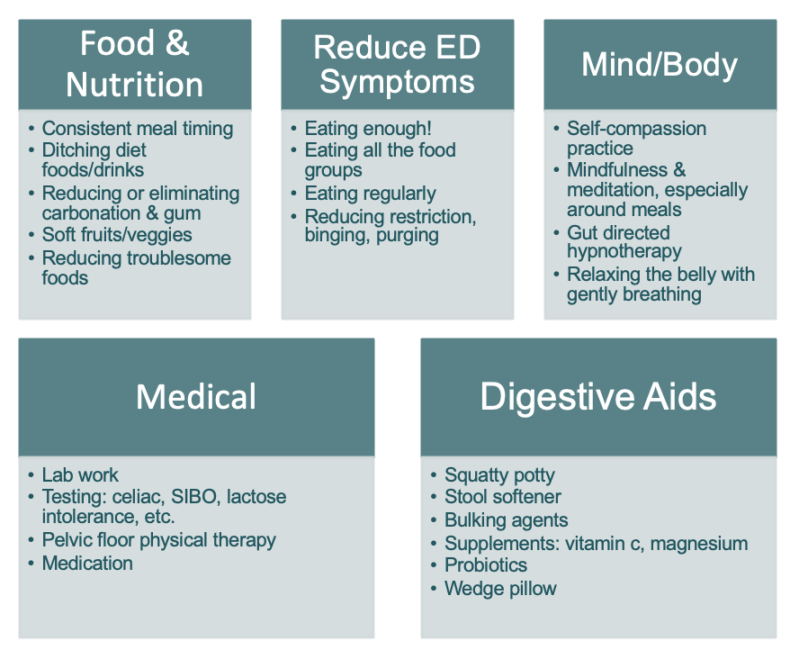

Beyond Food Restriction: 23 Essential
Tools for Treating Digestive and Eating Disorders

For folks with an eating disorder, some (but not all!) digestive symptoms require long-term management as opposed to one-and-done fixes. Your nervous system starts in your head and connects to your gut. So, supporting your digestive system will require utilizing tools beyond just a focus on food.

The primary digestive symptoms I would like to focus on include:

The likely pathways to these symptoms include:

I have noticed that these symptoms are exacerbated by:

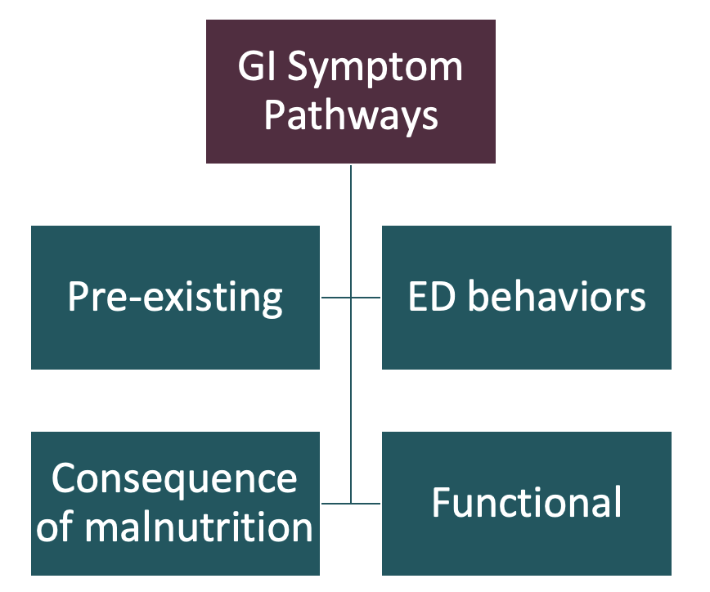

Choose a collection of tools to experiment with.
You do not have to do them all at once!

Tool 1: Food and Nutrition

Tool 2: Reduce ED Symptoms

Tool 3: Mind/Body

Tool 4: Medical

Tool 5: Digestive Aids

Next Steps
About Lauren
As the owner at Dear Nutrition, Lauren brings warmth, expertise, and a deeply personal understanding to her work in digestive health and eating disorders. Her approach is shaped by years of experience in nutrition education, organic farming, and her own GI diagnosis.
Lauren sees clients in person in Melrose, MA and virtually in MA, NY, CT, CA, VA, and NJ.
Lauren is a contributing author to The EDGI Project: Comprehensive Nutrition Therapy for Co-Occurring Gastrointestinal Disorders & Eating Disorders., a handbook for dietitians.
We hope this guide provides you with both answers and solutions for working at this complex intersection of digestive disorders and eating disorders. While there are no easy answers, our clients need providers who are willing to dig deep and explore a variety of tools to support their health and healing. Your clients are lucky to have you!

If you are looking to deepen your knowledge and skills on this topic, you can click here to learn more about our online course, “Digestive Disorders and Eating Disorders: A Complicated Mix.”
About Marci
Marci identifies as a Food and Body Imager Healer® practicing from a weight-inclusive, anti-oppression lens. Marci is a Certified Eating Disorder Registered Dietitian and Supervisor (CEDS-C) and a Certified Intuitive Eating Counselor.
In addition to her private practice, Marci launched an online eating disorders training platform for clinicians in 2015. In 2016, she joined the Simmons University nutrition department, where she co-developed a specialized eating disorder internship and continues to teach graduate-level courses in nutrition counseling for eating disorders. In 2018, she received the Professional Integrity Award from the Behavioral Health Nutrition Dietetic Practice Group of the Academy of Nutrition and Dietetics.
Her forthcoming book, Eating Disorders Treatment: A Comprehensive and Integrative Guide to Nutrition Therapy, is slated for publication in late Fall of this year. To learn more about her work, trainings, and publications, visit www.marcird.com. She also maintains a professional presence on social media under the username @marciRD.


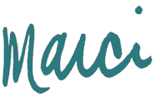
Warmly,
&
If you have questions including offerings including ones about Marci’s online training programs, please email our team at admin@marciRD.com.

